**Lesson 07 Demo 7**

**Set up Terraform**



**Steps to be performed:**

1. Download the appropriate package
2. Add the binary file to the **bin** directory

**Step 1: Download the appropriate package**

1.1 Create a folder

***mkdir test***

***cd test***

1.2 Run the following command to download the appropriate package

***wget*** [***https://releases.hashicorp.com/terraform/0.14.9/terraform_0.14.9_linux_amd64.zip***](https://releases.hashicorp.com/terraform/0.14.9/terraform_0.14.9_linux_amd64.zip)

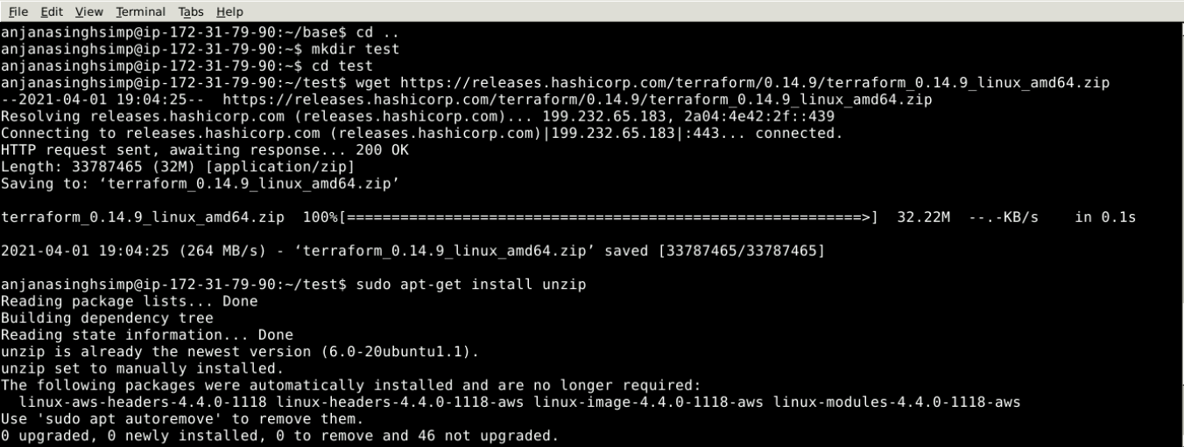

**Step 2: Add the binary file into the bin directory**

2.1 Run the below set of commands to download, unzip, and move the terraform binary file to the **bin** directory:

***sudo apt-get install unzip***

***unzip <YourTerraformFileName>.zip***

***sudo su***

***mv <YourUnzippedTerraformFileName> /usr/local/bin***

***cd ..***

***terraform -version***

